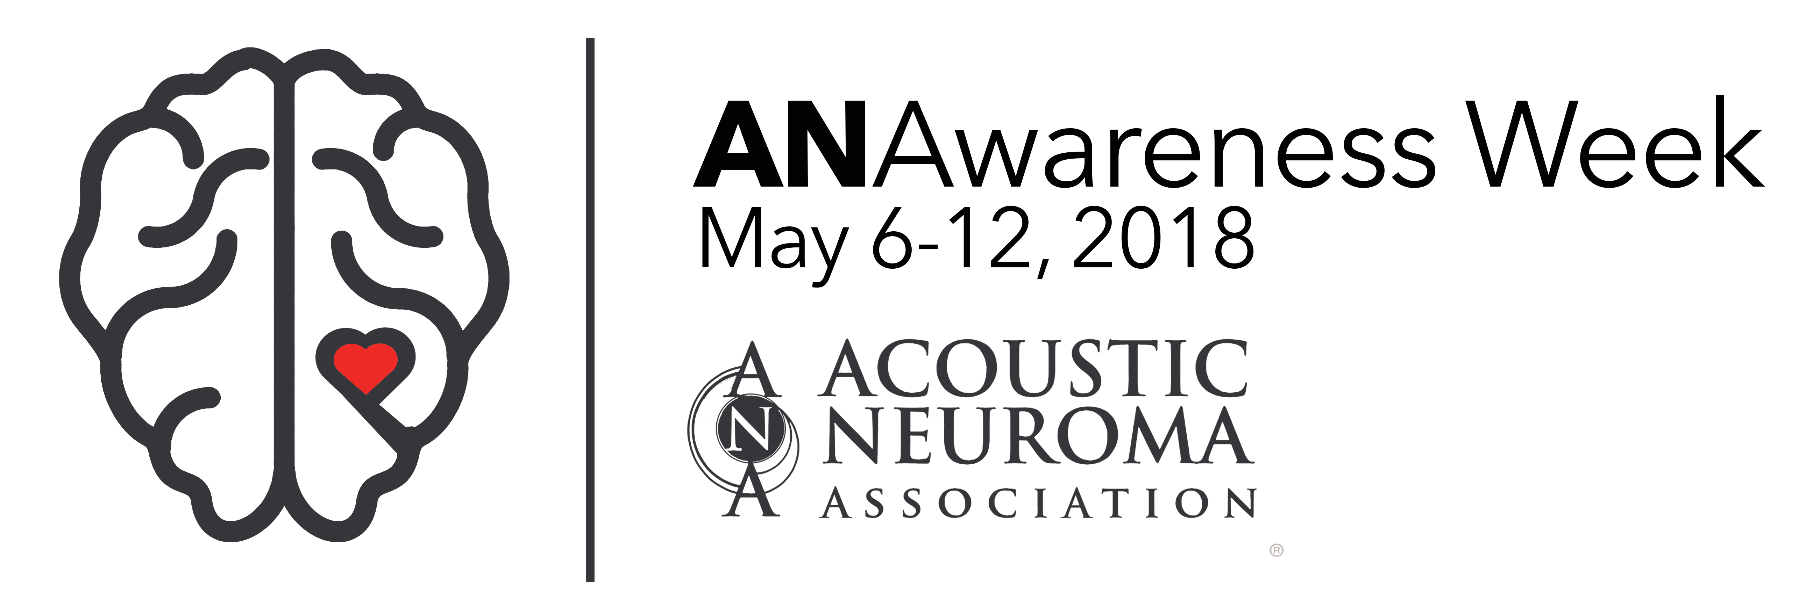

FOR IMMEDIATE RELEASE – (Insert date)

LOCAL CONTACT: (optional) Your name, Phone, Email
MEDIA CONTACT: Allison S. Feldman, Acoustic Neuroma Association, 770-205-8211, info@ANAUSA.org or www.ANAUSA.org
(Insert city name) resident explains life with rare brain tumor
to promote awareness

(Insert city, state)- (Insert city name) resident (insert your name) has a rare brain tumor called an acoustic neuroma and will take part in a nationwide campaign to raise awareness during the sixth annual ANAwareness Week May 6 to 12, 2018.

(Include 3-5 sentences about your personal AN journey. Notable mentions could include the size of your tumor, the symptoms you experienced, how long symptoms persisted before diagnosis, if you are a pre-or post-treatment or observation patient, the side effects that you struggle with daily and how you are adjusting to your new normal reality. You must be brief and if the media picks up the story, a reporter will contact you for more information.)

(Insert a quote from yourself here about why it is important for other people to know about acoustic neuroma. For example, <Insert your last name> recalls, “I felt so isolated after my diagnosis because no one knew what I was going through. When I found out that there was a vast network of people all over the nation just like me, I was filled with joy.”)

The medical advisory board of the Acoustic Neuroma Association (ANA) reports that diagnosis is nearly 3.5 persons per 100,000 and 5,000 are diagnosed annually in the U.S. There is no known cause for acoustic neuroma.

The early symptoms may include a reduction in hearing in the tumor ear, ringing in the ears, a feeling of fullness in the affected ear, balance issues and/or facial numbness. Without an MRI with contrast, these early symptoms are sometimes mistaken for normal changes of aging or attributed to noise exposure earlier in life and therefore the diagnosis is often delayed.

That is why campaigns such as ANAwareness Week are so critical.
(If you are taking part in any other awareness opportunities, insert a quote about that here. For example, “I started a fundraiser for the Acoustic Neuroma Association so it can continue to provide much needed services to others like me,” explains <insert your last name>.)

ANAwareness Week takes place during Brain Tumor Awareness Month each May. This awareness campaign was started in 2013 by ANA, a non-profit organization founded in 1981 and located in metro Atlanta representing nearly 5,000 acoustic neuroma patients, caregivers, family members and medical professionals worldwide providing information regarding all treatment options.
For more information about acoustic neuromas and ANAwareness Week, visit www.ANAUSA.org.
Note: In no case does ANA endorse any commercial product, physician, surgeon, medical procedure, medical institution or its staff.
###

